Jenkins

-Plugins worked on

-maven, slack,gmail,pipeline

Github.

-how we create a branch

-diff b/w fetch and pull

Docker

Ansible

-what is ansible? How do you create?

-use case: let’s say we have 100 machines if we want restart all the machines write the yaml script and run the ansible playbook

Puppet

-similarly, for puppet use time interval

1) Explain what is DevOps?

DevOps is culture emphasizing the collaboration and communication between the developers and operations team in order to improve the deployment frequency for faster and better results and reducing the failure rate of releases.

2). Mention what are the key aspects or principle behind DevOps?

The key aspects or principle behind DevOps is

Infrastructure as code

Continuous deployment

Automation

Monitoring

Security

Infrastructure as code is the practice of treating infrastructure as if it were code — just like software, in fact.

Treating infrastructure as if it were **code lets you adopt powerful practices** that have been used by software developers for years, and with great success-

**practices that include** version control, peer review, automated testing, release tagging, release promotion, and Continuous Delivery.

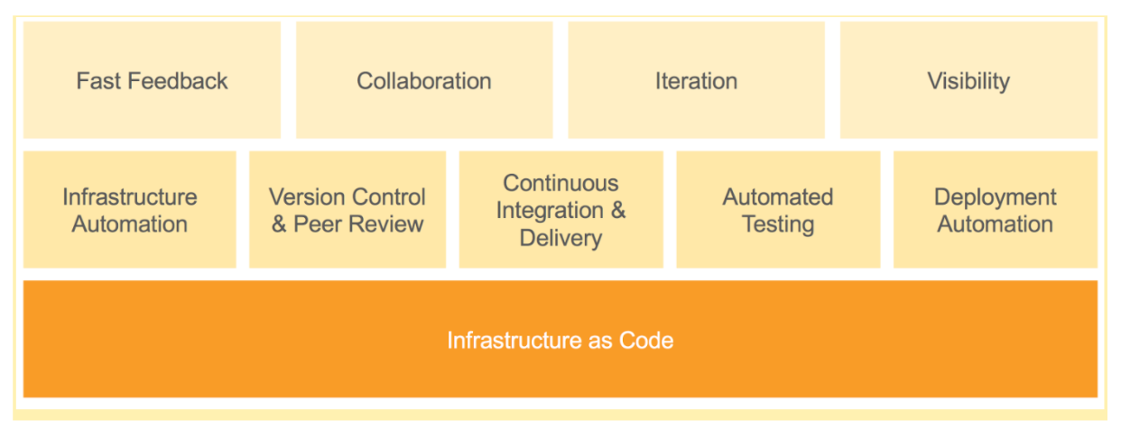

The wide adoption of virtualization and self-service cloud infrastructure has shifted the bottleneck from allocating servers to configuring them. Where it used to take weeks or months to allocate a server, now it can be done in a minute or two.

These new challenges require a change to the way IT works, but the primary challenges are the same as they’ve always been:

* **Develop the most reasonable change for a problem**, then propose its adoption into the main codebase through a pull request.
* **Reasonably prove a given change is safe and correct** by deploying it to a production-like environment and running a sufficient number of tests.
* **Orchestrate change** to a potentially large and complex portion of the infrastructure.
* **Know at any moment the current state** of any part of the infrastructure — especially its health.
* **Know the history of any configuration** — including who proposed it, who approved, and when it was applied.
* Do all of the above as **quickly, efficiently, reliably, and securely** as possible

To address these challenges at modern scale (both in terms of infrastructure and organization) while still keeping up with the needs of the business (not to mention keeping the lights on), you need new methods of collaborating, delivering, and gaining situational awareness.

3)What are the core operations of DevOps with application development and with infrastructure?

The core operations of DevOps with Application development

Code building

Code coverage

Unit testing

Packaging

Deployment

The core operations of DevOps with infrastructure

Provisioning

Configuration

Orchestration

Deployment

4) Explain how “Infrastructure of code” is processed or executed in AWS?

In AWS,

The code for infrastructure will be in simple JSON format

This JSON code will be organized into files called templates

These templates can be deployed on AWS and then managed as stacks

Later the CloudFormation service will do the Creating, deleting, updating, etc. operation in the stack

5) Explain which scripting language is most important for a DevOps engineer?

A simpler scripting language will be better for a DevOps engineer. Python seems to be very popular.

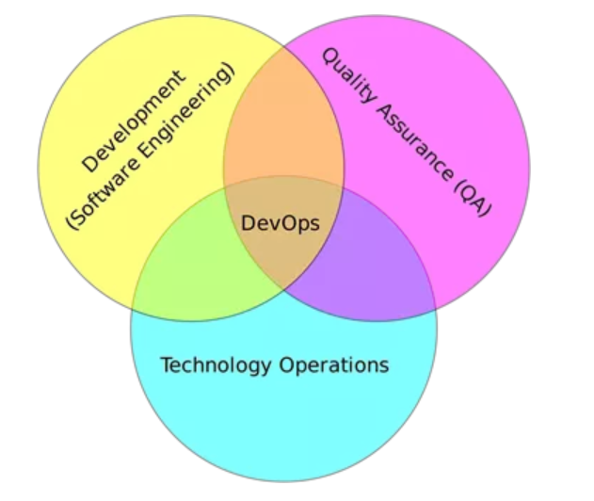

6) Explain how DevOps is helpful to developers?

DevOps can be helpful to developers to fix the bug and implement new features quickly. It also helps for clearer communication between the team members.

7) List out some popular tools for DevOps?

Some of the popular tools for DevOps are

* Jenkins
* Nagios
* Monit
* ELK (Elasticsearch, Logstash, Kibana)
* io
* Jenkins
* Docker
* Ansible
* Git
* Collectd/Collectl

8) Mention at what instance have you used the SSH?

I have used SSH to log into a remote machine and work on the command line.  Beside this, I have also used it to tunnel into the system in order to facilitate secure encrypted communications between two untrusted hosts over an insecure network.

9) Explain how would you handle revision (version) control?

My approach to handle revision control would be to post the code on SourceForge or GitHub so everyone can view it.  Also, I will post the checklist from the last revision to make sure that any unsolved issues are resolved.

10) Mention what are the types of Http requests?

The types of Http requests are

* GET
* HEAD
* PUT
* POST
* PATCH
* DELETE
* TRACE
* CONNECT
* OPTIONS

11) Explain what would you check If a Linux-build-server suddenly starts getting slow?

If a Linux-build-server suddenly starts getting slow, you will check for following three things

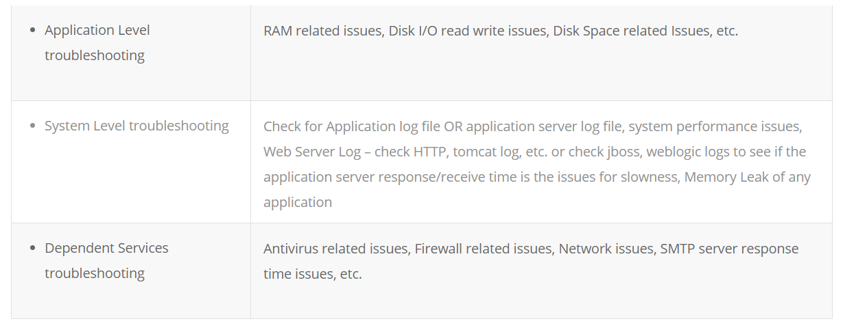

12) Whether your video card can run Unity how would you know?

When you use command



|  |  |
| --- | --- |
| 1 | /usr/lib/nux/unity_support_test-p |

it will give detailed output about Unity’s requirements and  if they are met, then your video card can run unity.

13) Explain how to enable startup sound in Ubuntu?

To enable startup sound

* Click control gear and then click on Startup Applications
* In the Startup Application Preferences window, click Add to add an entry
* Then fill the information in comment box like Name, Command and Comment



|  |  |
| --- | --- |
| 1 | /usr/bin/canberra-gtk-play—id= “desktop-login”—description= “play login sound” |

* Logout and then login once you are done

You can also open it with shortcut key Ctrl+Alt+T.

14) What is the quicker way to open an Ubuntu terminal in a particular directory?

To open Ubuntu terminal in a particular directory you can use custom keyboard short cut.

To do that, in the command field of a new custom keyboard , type genome – terminal – – working – directory = /path/to/dir.

15) Explain how you can get the current color of the current screen on the Ubuntu desktop?

You can open the background image in The Gimp (image editor) and then use the dropper tool to select the color on the specific point. It gives you the RGB value of the color at that point.

16) Explain how you create launchers on desktop in Ubuntu?

To create launchers on desktop in Ubuntu you can use

ALT+F2 then type “ gnome-desktop-item-edit –create-new~/desktop “,  it will launch the old GUI dialog and create a launcher on your desktop

17) Explain what is Memcached?

Memcached is a free and open source, high-performance, distributed memory object caching system. The primary objective of Memcached is to enhance the response time for data that can otherwise be recovered or constructed from some other source or database. It is used to avoid the need to operate SQL data base or another source repetitively to fetch data for concurrent request.

Memcached can be used for

• Social Networking -> Profile Caching  
• Content Aggregation -> HTML/ Page Caching  
• Ad targeting -> Cookie/profile tracking  
• Relationship -> Session caching  
• E-commerce -> Session and HTML caching  
• Location-based services -> Data-base query scaling  
• Gaming and entertainment -> Session caching

Memcache helps in

• Speed up application processes  
• It determines what to store and what not to  
• Reduce the number of retrieval requests to the database  
• Cuts down the I/O ( Input/Output) access (hard disk)

Drawback of Memcached is

• It is not a persistent data store  
• Not a database  
• It is not an application specific  
• It cannot cache large object

18) Mention some important features of Memcached?

Important features of Memcached includes

• CAS Tokens: A CAS token is attached to any object retrieved from cache. You can use that token to save your updated object.  
• Callbacks: It simplifies the code  
• getDelayed: It reduces the delay time of your script which is waiting for results to come back from server  
• Binary protocol: You can use binary protocol instead of ASCII with the newer client  
• Igbinary: Previously, client always used to do serialization of the value with complex data, but with Memcached you can use igbinary option.

19) Explain whether it is possible to share a single instance of a Memcache between multiple projects?

Yes, it is possible to share a single instance of Memcache between multiple projects. Memcache is a memory store space, and you can run memcache on one or more servers. You can also configure your client to speak to a particular set of instances. So, you can run two different Memcache processes on the same host and yet they are completely independent. Unless, if you have partitioned your data, then it becomes necessary to know from which instance to get the data from or to put into.

20)You are having multiple Memcache servers, in which one of the memcacher server fails, and it has your data, will it ever try to get key data from that one failed server?

The data in the failed server won’t get removed, but there is a provision for auto-failure, which you can configure for multiple nodes. Fail-over can be triggered during any kind of socket or Memcached server level errors and not during normal client errors like adding an existing key, etc.

21) Explain how you can minimize the Memcached server outages?

•  When one instance fails, several of them goes down, this will put larger load on the database server when lost data is reloaded as client make a request. To avoid this, if your code has been written to minimize cache stampedes then it will leave a minimal impact  
•  Another way is to bring up an instance of Memcached on a new machine using the lost machines IP address  
•  Code is another option to minimize server outages as it gives you the liberty to change the Memcached server list with minimal work  
•  Setting timeout value is another option that some Memcached clients implement for Memcached server outage. When your Memcached server goes down, the client will keep trying to send a request till the time-out limit is reached

22) Explain how you can update Memcached when data changes?

When data changes you can update Memcached by

• Clearing the Cache proactively: Clearing the cache when an insert or update is made  
• Resetting the Cache: It is similar to the first method but rather than just deleting the keys and waiting for the next request for the data to refresh the cache, reset the values after the insert or update.

23) Explain what is Dogpile effect? How can you prevent this effect?

Dogpile effect is referred to the event when cache expires, and websites are hit by the multiple requests made by the client at the same time. This effect can be prevented by using semaphore lock. In this system when value expires, first process acquires the lock and starts generating new value.

24) Explain how Memcached should not be used?

• Memcached common misuse is to use it as a data store, and not as a cache  
• Never use Memcached as the only source of the information you need to run your application. Data should always be available through another source as well  
• Memcached is just a key or value store and cannot perform query over the data or iterate over the contents to extract information  
• Memcached does not offer any form of security either in encryption or authentication

25) When server gets shut down does data stored in Memcached is still available?

Data stored in Memcached is not durable so if server is shut down or restarted then all the data stored in Memcached is deleted.

26) Mention what is the difference between Memcache and Memcached?

• Memcache: It is an extension that allows you to work through handy object-oriented (OOP’s) and procedural interfaces. It is designed to reduce database load in dynamic web applications.

• Memcached: It is an extension that uses libmemcached library to provide API for communicating with Memcached servers. It is used to increase the dynamic web applications by alleviating database load. It is the latest API.